**REAL-TIME MACHINE LEARNING MODELS FOR EARLY SEPSIS DETECTION USING CONTINUOUS PATIENT DATA MONITORING**

**Table of Contents**

Chapter 1: Introduction 3

1.1 Contribution 3

1.2 Research Questions 4

1.3 Research Hypothesis 5

1.4 Research Objectives 5

Chapter 2: Research Background 6

Chapter 3: Methodology 10

3.1 Data Collection 10

3.2 Data Preprocessing 10

3.3 Calculation of Sepsis Scores (SOFA and qSOFA) 11

3.4 Class Imbalance Handling 14

3.5 Feature Selection 14

3.6 Model Development 15

3.7 Model Evaluation 15

3.8 Ethical Considerations 16

Chapter 4: Design and Implementation 18

Reference List 26

# Chapter 1: Introduction

## 1.1 Contribution

Sepsis remains a serious difficulty in healthcare, in charge of sizable morbidity as well as mortality around international hospital settings. Despite its higher stakes, early detection of sepsis continues to be actually challenging due to its understated very early symptoms and fast advancement. Although commonly utilized in clinical environments, traditional scoring systems like the Sequential Organ Failure Assessment (SOFA) and quick SOFA (qSOFA) often fall short in recognizing sepsis in its first stages, mostly given that these systems are structured around corrected criteria as opposed to adaptive learning from real-time patient data (Yan *et al.* 2022). This research finds to unite these gaps by leveraging real-time machine learning models, primarily Random Forest as well as XGBoost, to refine continuous flows of patient data. These models offer a notable perk by acknowledging complex, often nonlinear communications, one of numerous physiological parameters, improving the accuracy as well as timeliness of sepsis detection.

Traditional sepsis detection systems, like SOFA and qSOFA, are actually based upon fixed scoring systems that rely upon particular thresholds of patient vital signs, including blood pressure, respiratory rate, and also heart rate. These criteria work but are actually generally stationary and stiff, frequently failing to capture the nuanced, dynamic changes that can show the onset of sepsis (Giacobbe *et al.* 2021). Consequently, these systems might disregard the early sign, especially when symptoms do not get to clinically significant thresholds in the early phases of sepsis. For instance, SOFA and qSOFA ratings demand certain levels of organ dysfunction to be satisfied before indicating a higher sepsis risk. Therefore, the window for early intervention is usually skipped, which may result in aggravated patient outcomes, long term hospital stays, and also higher healthcare costs.

Furthermore, traditional scoring systems usually call for manual data entry and also computation, launching problems as well as achievable errors in assessment. In busy clinical environments, the manual nature of these processes can easily prevent timely intervention, as healthcare providers may lack the quick data or even computational sources to determine and interpret these ratings (Bedoya *et al.* 2021). This job deals with these restrictions through recommending a model that continually checks and processes incoming patient data streams, automating early detection while lowering the dependence on manual input.

The proposed strategy's unique aspect depends on carrying out machine learning models, primarily Random Forest and XGBoost, within a real-time patient monitoring system. Unlike traditional models, Random Forest and also XGBoost are certainly not limited to predefined, straight relationships, one of variables. These models can successfully pinpoint complex patterns in huge datasets by analyzing interactions among a number of vital signs and also lab results (Kijpaisalratana *et al.* 2022). By taking advantage of continuous data streams, they may record minor, typically imperceptible changes in a patient's condition that might signal an impending sepsis activity. For example, subtle yet consistent changes in heart rate irregularity, blood pressure, or oxygen saturation could be hailed as high-risk, even though they remain within suggested clinical restrictions. Random Forest, an ensemble learning model, functions by creating a number of decision trees and accumulating their outputs, making it strong against overfitting and also successful in high-dimensional, loud data settings (Ocampo-Quintero *et al.* 2022). On the other hand, XGBoost, an improved gradient-boosting algorithm, excels at recording complex, nonlinear connections as well as is known for its own remarkable accuracy and also computational efficiency. Blended, these models give a robust framework for analyzing patient data with higher sensitivity and also specificity, creating all of them ideally matched for real-time sepsis prediction.

An essential contribution of the research hinges on its potential to enhance both the timeliness and accuracy of sepsis detection. Traditional sepsis scoring systems normally work out credit ratings based upon regular, distinct measurements, overlooking the continuous, real-time monitoring that machine learning models enable (Moor *et al.* 2021). By combining Random Forest and also XGBoost in a real-time monitoring configuration, this task aims to enrich the capability to detect sepsis at an earlier phase, which could possibly bring about a notable reduction in sepsis-related mortality and also morbidity. Real-time analysis allows these models to adapt to a patient's evolving condition, using improved forecasts that assist clinical intervention at the earliest indicator of sepsis risk. Also, the machine learning models can bring about a reduction in false positives, a usual problem along with existing sepsis scoring systems (Singh *et al.* 2022). Higher false-positive rates can bring about needless treatments and also improved healthcare costs, as well as they might likewise bring about "alarm exhaustion" amongst healthcare providers. By concentrating on feature selection and optimizing the models based upon applicable patient data, this research strives to enhance prediction accuracy while decreasing false alarms, helping make the system extra reliable and also trusted for clinical usage.

## 1.2 Research Questions

* How effective are Random Forest and XGBoost models in detecting early signs of sepsis using continuous monitoring of patient vital signs and lab results, compared to existing clinical scoring systems like SOFA and qSOFA?
* What is the predictive accuracy of the Random Forest and XGBoost models for early sepsis detection, as measured by the Area Under the ROC Curve (AUC) and Precision-Recall metrics?
* In what ways do machine learning models reduce false positives in sepsis detection, and how does this impact clinical decision-making compare to standard methods like SOFA and qSOFA?
* What improvements in data collection, feature selection, and integration strategies are necessary to optimize real-time machine learning models for early sepsis detection in clinical settings?

## 1.3 Research Hypothesis

The integration of real-time Random Forest and XGBoost models will significantly improve the accuracy and timeliness of sepsis detection, outperforming traditional clinical scoring systems (SOFA and qSOFA), while reducing false positives and enhancing early intervention outcomes.

## 1.4 Research Objectives

* To develop and implement real-time Random Forest and XGBoost models for continuous monitoring of patient vital signs and lab results to detect early signs of sepsis.
* To evaluate model performance using Area Under the ROC Curve (AUC) and Precision-Recall metrics, ensuring accurate early detection while minimizing false positives.
* To compare model outputs with standard clinical sepsis scoring systems, such as SOFA and qSOFA, and assess improvements in early detection timing and accuracy.
* To recommend further improvements in model design and implementation, focusing on data collection methods, feature selection, and integration strategies for enhancing clinical applicability and effectiveness in sepsis prediction.

# Chapter 2: Research Background

***Current Challenges in Traditional Sepsis Detection Models (SOFA and qSOFA)***

Traditional sepsis detection models, consisting of the Sequential Organ Failure Assessment (SOFA) and quick SOFA (qSOFA), are actually commonly taken advantage of in clinical settings to establish sepsis risk based upon patient physiological data like blood pressure, respiratory rate, and mindset. While these scoring systems are actually practical for monitoring organ dysfunction along with sepsis advancement, they have distinct restraints in early sepsis detection (Islam *et al.* 2023). One essential barrier is their reliance on predefined threshold criteria. SOFA as well as also qSOFA credit rating rankings are actually based upon distinctive measurements that require clients to present comprehensive changes, including a drop in blood pressure or perhaps a growth in respiratory rate, to cross a diagnostic threshold. This stationary method often fails to capture subtle, early physiological changes linked with sepsis, which may show as very small varieties all over several variables as opposed to abrupt switches in any sort of sort of unique measurement (Deng *et al.* 2022). As a result, these models commonly miss very early signs, putting off important interventions.

However, one more restriction of SOFA in addition to qSOFA is that they count on intermittent monitoring, commonly entailing regular manual gain access to of patient data. This intermittent approach is actually vulnerable to hold-ups, as it relies on healthcare providers to often record, compute, as well as also decipher ratings. In high-paced clinical environments, there can be remarkable issues between data collection and also diagnosis, which could result in slower responses to wearing away conditions (Agnello *et al.* 2023). Offering the relevance of early sepsis intervention, any sort of delay may considerably reduce treatment efficacy and also increase mortality risk. Better, studies signify that SOFA and qSOFA models have reduced sensitivity for spotting sepsis in individuals along with abnormal or even light symptoms, causing possible under-diagnosis. According to Seymour *et al.* (2016), these models usually neglect to recognize sepsis until it has proceeded to a serious stage, restricting the opportunity for preventive interventions. These challenges highlight the need for a more adaptive, real-time service that may study dynamic data patterns to discover sepsis in its own earliest stages, thus inspiring the application of machine learning methods.

***Machine Learning Approaches in Healthcare and Sepsis Prediction***

Machine learning (ML) has actually ended up being a transformative device in healthcare, using brand-new procedures for predicting, identifying, and also handling complicated conditions like sepsis. Leveraging algorithms with the ability of taking care of substantial amounts of data, ML makes it possible for healthcare systems to produce real-time predictions, possibly enhancing patient outcomes (Honoré *et al.* 2023). In sepsis prediction, machine learning models, like Random Forest and also XGBoost, succeed because of their possible to capture intricate patterns as well as communications throughout many clinical variables, including heart rate, respiratory rate, temperature, as well as likewise lab results. Unlike traditional scoring systems like SOFA and also qSOFA, which trust pre-programmed thresholds, ML models utilize data-driven strategies to profit from patterns in historic data. Research researches like Fleuren *et al*. (2020) have in fact presented that Random Forest models are particularly productive in taking care of high-dimensional data, creating each of all of them appropriate for analyzing the continuous flows of vital signs significant for extremely early sepsis detection. Random Forest, with its own ensemble of decision trees, may handle complicated variable links and also handle missing data properly, each typical challenges in clinical settings.

XGBoost, a gradient-boosting algorithm, additionally gives substantial comforts in sepsis prediction. Identified for its accuracy and also rate, XGBoost iteratively improves prophecies, making it productive in time-sensitive therapies like early sepsis detection. In research through Misra *et al.* (2021), XGBoost showed higher precision in pinpointing sepsis onset, outrunning traditional models as well as additionally lowering false positives, an essential improvement that may prevent unnecessary interventions. Atop that, machine learning procedures are in fact extremely versatile to real-time clinical settings, where patient data continually flows from monitoring tools. This versatility makes it possible for a lot prompter risk assessment, permitting healthcare providers to intervene earlier. Overall, machine learning stands for a considerable progression in sepsis prediction, giving strengthened accuracy, timeliness, and also the opportunity for real-time integration, certainly addressing the voids left behind by routine tactics in extremely early sepsis detection.

***Real-Time Data Integration and Continuous Monitoring in Clinical Settings***

Real-time data integration in addition to continuous monitoring in clinical environments are actually significant for enhancing early detection of essential conditions like sepsis. Modern hospital settings are geared up with a variety of monitoring devices that continually accumulate patient data, containing vital signs, lab results, and also various other health metrics (Ericson *et al.* 2022). Having said that, the difficulty depends on properly utilizing this data in real-time to strengthen decision-making as well as also patient outcomes. Existing practices normally include intermittent data entrance and manual scoring estimations, which may easily delay the acknowledgment of essential health tasks like sepsis. Real-time data integration may link this area through making it possible for instant analysis as well as response. Researchers, featuring those anxiety that including continuous monitoring data along with machine learning algorithms can conveniently enrich sepsis detection through analyzing patient data streams as they are accumulated. Machine learning models like Random Forest and XGBoost are specifically effective in processing high-frequency data from numerous resources, spotting elaborate patterns as well as communications that might symbolize quite early sepsis (Persson *et al.* 2021). These models may effortlessly run in real-time, flagging feasible complications quicker than traditional scoring methods, which commonly rely upon predefined thresholds and also repaired evaluations.

Implementing continuous monitoring as well as also real-time data integration calls for shaking off specialized challenges, including data synchronization, handling missing worths, and likewise taking care of data circulation originating from a variety of devices. Data interoperability in between different systems is actually also important to guarantee that patient data is consolidated and readily on call for analysis (Alanazi *et al.* 2023). Advanced algorithms can easily take care of these intricacies by adapting to data inconsistencies as well as maintaining accurate prophecies, creating continuous monitoring a lot more feasible in clinical settings. Real-time data integration eventually enables additional proactive interventions, minimizing the delay between sepsis onset as well as treatment. This method certainly not just enhances prediction accuracy but additionally sustains healthcare providers in producing informed, timely selections, enhancing patient outcomes and decreasing mortality costs connected with conditions like sepsis.

***Evaluating Model Performance in Sepsis Detection***

Analyzing model performance in sepsis detection is actually necessary to ensure that machine learning models offer exact, reliable predictions that can enrich patient outcomes. Typical evaluation metrics in this particular field include the Area Under the Receiver Operating Characteristic Curve (AUC-ROC) and also Precision-Recall (PR) metrics. These metrics are actually widely utilized in healthcare predictive modeling because of their capacity to gauge both the sensitivity and specificity of models, which are actually vital for conditions like sepsis where false negatives can cause intense patient outcomes, and false positives can cause excessive treatments and also raised source usage (Burdick *et al.* 2020). The AUC-ROC measurement assesses a model's capability to compare courses (e.g., sepsis vs. no sepsis) around a variety of threshold settings. A higher AUC indicates that the model works at properly recognizing people at risk of sepsis without extreme false alarms. In sepsis detection, an AUC closer to 1.0 recommends that the model executes properly in pinpointing understated early signs of sepsis, as displayed through studies like those by Wang *et al.* (2022). This is actually particularly vital for real-time uses where accuracy is actually paramount to steer clear of put off interventions.

Precision-Recall metrics, alternatively, are actually specifically applicable in unbalanced datasets, where one course (e.g., sepsis cases) is a lot smaller than the other (non-sepsis cases). In these cases, precision reflects the model's capability to supply precise sepsis prophecies without featuring too many false positives, while recall presents the model's success in recognizing genuine sepsis cases. Higher precision and recall credit ratings suggest the model properly pinpoints sepsis clients early, reducing the risk of missing out on crucial scenarios (Lin *et al.* 2021). Using AUC-ROC and Precision-Recall makes it possible for analysts and also specialists to evaluate model robustness and fine-tune criteria to assault an equilibrium between timely detection as well as minimizing false positives. Helpful model evaluation therefore supplies ideas right into just how machine learning models contrast to traditional scoring systems, assisting their potential integration into clinical environments for real-time sepsis detection.

# Chapter 3: Methodology

## 3.1 Data Collection

The dataset made use of for this study was sourced coming from the UCI Artificial Intelligence Repository, especially coming from the Sepsis Survival Minimal Clinical Records dataset. This dataset was picked up from 110,204 admissions of 84,811 hospitalized patients in Norway in between 2011 as well as 2012. The patients were diagnosed with different conditions connected to sepsis, including infections, widespread inflamed response syndrome (SIRS), sepsis through original microorganisms, or even septic shock. The task of predicting the survival status of these patients is important, as sepsis is a lethal disorder that may trigger rapid organ failure as well as fatality, frequently within hours (Agnello *et al.* 2023).

The dataset is arranged into 2 primary cohorts: the Sepsis Survival Primary Cohort and the Sepsis Survival Validation Cohort. The primary cohort includes data from patients along with potential prerequisites to sepsis (ante Sepsis-3 interpretation), while the study cohort pays attention to patients described due to the unfamiliar Sepsis-3 requirements. Also, the validation cohort, that includes 137 patients from South Korea, acts as an external validation prepared for reviewing the generalizability of the predictive models.

This dataset has vital clinical variables such as age, gender, and clinical measures like platelet count and bilirubin levels. It is structured for a classification task where the objective is to anticipate whether a patient endured or even died around nine times after their medical record was picked up (Islam *et al.* 2023). The dataset performs no call for added preprocessing, as categorical variables have presently been encrypted. It is also necessary to note that the dataset contains delicate information, featuring demographic details like age and gender, which should be handled with proper privacy considerations.

***Dataset Link:*** https://archive.ics.uci.edu/dataset/827/sepsis+survival+minimal+clinical+records

## 3.2 Data Preprocessing

Data preprocessing is a necessary step to ensure that the dataset is clean, steady, and prepared for analysis. In this particular study, many preprocessing techniques were hired to prepare the Sepsis Survival dataset for artificial intelligence applications.

***Handling Missing Values***

The very first step in preprocessing was to check for missing values in the dataset. This was carried out using the.isnull().amount() technique to add up the amount of missing access in each component. As soon as determined, the missing values were taken care of based upon their attributes as well as distribution. If the missing data was minimal and randomly circulated, it was imputed along with the mean, mean, or even method, depending upon the kind of attribute (continuous or categorical). Just in case where the missing values were substantial and can potentially distort model performance, the impacted rows were taken out to maintain the integrity of the dataset.

***Outlier Detection and Removal***

Outliers in continuous variables were identified making use of boxplots and the Interquartile Variety (IQR) strategy. Particularly, the 'age_years' feature, which stands for the age of patients, was looked at. Outliers beyond an affordable age range (e.g., patients under 18 or even over 120 years old) were cleared away, as they were deemed to become erroneous or even non-representative of the target population. This helped guarantee an extra constant dataset that would certainly result in more precise model forecasts.

***Feature Engineering***

Several feature engineering techniques were applied to enrich the dataset and enhance the predictive power of the machine learning models.

* ***Creation of Age Groups:*** The 'age_years' attribute was sorted into 10-year intervals to generate a brand-new categorical component, 'age_group_10yr.' This change arranged patients into workable age categories, making the model a lot more illustratable and possibly boosting predictive performance.
* ***Synthetic Data Generation:*** To simulate clinical measures required for sepsis recording bodies, including the PaO2/FiO2 ratio as well as platelet count, random values were produced within a plausible array. A typical range of one hundred to 500 was used, as worths outside this variety are unusual in sepsis scenarios. Random values between 50 and 400 (x10^3/ μL) imitate reasonable matters observed in sepsis patients for Platelet count. Bilirubin levels, MAP, creatinine, and various other variables were likewise created within clinical ranges, guaranteeing that created data was sensible for use in computing sepsis scores.

## 3.3 Calculation of Sepsis Scores (SOFA and qSOFA)

**Calculation of SOFA**

The SOFA score assesses the degree of organ failing in all over six units: respiratory, coagulation, liver, cardiovascular, renal, and neurological (Yang, 2024). Each organ system is assessed using specific clinical parameters, with scores ranging from 0 (normal function) to 4 (severe dysfunction). The complete SOFA score is the sum of scores all over all six systems, with a max possible score of 24. Greater SOFA scores suggest even more serious organ dysfunction as well as are connected with a greater risk of mortality.

***Respiratory (PaO2/FiO2 ratio)***

PaO2/FiO2 is the ratio of partial pressure of oxygen to the fraction of inspired oxygen, which reflects the severity of respiratory failure.

* PaO2/FiO2 > 400: Score = 0 (Normal)
* PaO2/FiO2 300–400: Score = 1 (Mild dysfunction)
* PaO2/FiO2 200–300: Score = 2 (Moderate dysfunction)
* PaO2/FiO2 100–200: Score = 3 (Severe dysfunction)
* PaO2/FiO2 < 100: Score = 4 (Very severe dysfunction)

***Coagulation (Platelet count)***

Platelet count reflects the ability of the blood to clot (Alanazi *et al.* 2023). A lower platelet count indicates more severe coagulation dysfunction.

* Platelet count > 150: Score = 0 (Normal)
* Platelet count 100–150: Score = 1 (Mild dysfunction)
* Platelet count 50–100: Score = 2 (Moderate dysfunction)
* Platelet count 20–50: Score = 3 (Severe dysfunction)
* Platelet count < 20: Score = 4 (Very severe dysfunction)

***Liver (Bilirubin levels)***

Bilirubin is a byproduct of red blood cell breakdown, and elevated levels indicate impaired liver function.

* Bilirubin < 1.2 mg/dL: Score = 0 (Normal)
* Bilirubin 1.2–2 mg/dL: Score = 1 (Mild dysfunction)
* Bilirubin 2–3 mg/dL: Score = 2 (Moderate dysfunction)
* Bilirubin 3–6 mg/dL: Score = 3 (Severe dysfunction)
* Bilirubin > 6 mg/dL: Score = 4 (Very severe dysfunction)

***Cardiovascular (Mean Arterial Pressure - MAP)***

MAP is a key indicator of circulatory perfusion (Giordano *et al.* 2024). A lower MAP reflects worse cardiovascular function and possible shock.

* MAP ≥ 70 mmHg: Score = 0 (Normal)
* MAP 50–69 mmHg: Score = 1 (Mild dysfunction)
* MAP 40–49 mmHg: Score = 2 (Moderate dysfunction)
* MAP < 40 mmHg: Score = 3 (Severe dysfunction)

***Renal (Creatinine levels)***

Creatinine is a waste product filtered by the kidneys, and elevated levels indicate kidney dysfunction (Yang *et al.* 2023).

* Creatinine ≤ 1.2 mg/dL: Score = 0 (Normal)
* Creatinine 1.2–2 mg/dL: Score = 1 (Mild dysfunction)
* Creatinine 2–3 mg/dL: Score = 2 (Moderate dysfunction)
* Creatinine 3–4 mg/dL: Score = 3 (Severe dysfunction)
* Creatinine > 4 mg/dL: Score = 4 (Very severe dysfunction)

***Neurological (Glasgow Coma Scale - GCS)***

GCS assesses the level of consciousness, with lower scores indicating worse neurological function.

* GCS 15: Score = 0 (Normal)
* GCS 13–14: Score = 1 (Mild dysfunction)
* GCS 10–12: Score = 2 (Moderate dysfunction)
* GCS 3–9: Score = 3 (Severe dysfunction)
* GCS < 3: Score = 4 (Very severe dysfunction)

The total SOFA score is obtained by summing the individual scores across these six systems. A higher SOFA score indicates a greater level of organ dysfunction and is associated with a higher risk of mortality (Zhang *et al.* 2023).

**Calculation of qSOFA Score**

The qSOFA (fast SOFA) score is a streamlined model of the SOFA score, designed for rapid assessment in emergency setups (Gao *et al.* 2023). It is based upon 3 clinical parameters as well as is made use of to identify patients that might be at high risk for sepsis-related complications. The qSOFA score ranges from 0 to 3, along with greater market values suggesting greater risk of sepsis-related mortality.

***Respiratory rate***

A respiratory rate of ≥22 breaths per minute is considered abnormal and increases the qSOFA score.

* Score: 1 if respiratory rate ≥ 22 breaths per minute.

***Altered mental status (Glasgow Coma Scale)***

A GCS < 15 suggests altered mental status, a common sign of sepsis and organ dysfunction (Prasad *et al.* 2023).

* Score: 1 if GCS < 15.

***Systolic blood pressure***

A systolic blood pressure ≤ 100 mmHg is indicative of cardiovascular instability, which is commonly observed in severe sepsis or septic shock.

* Score: 1 if systolic BP ≤ 100 mmHg.

The overall qSOFA score is calculated by including the scores for these 3 parameters. A qSOFA score of 2 or even more proposes that a patient is at higher risk of poor outcomes because of sepsis and demands additional clinical focus.

## 3.4 Class Imbalance Handling

Class imbalance is a usual problem in predictive modeling, particularly in medical datasets where the variety of patients that survive is typically substantially more than those who certainly do not (Aguirre and Urrechaga, 2023). To address this, SMOTE (Synthetic Minority Over-sampling Technique) was put on to stabilize the classes in the Sepsis Survival dataset. SMOTE is an oversampling approach that creates synthetic examples for the minority class (in this scenario, deceased patients) through inserting in between existing cases. This assists to avoid the machine learning models coming from being prejudiced towards the bulk class (surviving patients) and makes certain that the model profits from each class similarly. Through administering SMOTE, the dataset was created extra well balanced, improving the model's capability to anticipate both heirs and non-survivors properly, therefore bringing about better generalization as well as performance in categorizing patient outcomes.

## 3.5 Feature Selection

Feature collection is a critical action in cultivating effective predictive models, as it makes sure that only one of the most pertinent variables are featured in the analysis. For this study, a combination of demographic, clinical, as well as sepsis scoring features were chosen based on their importance to sepsis diagnosis as well as survival outcomes.

* ***Demographic Features:*** Age and gender were featured as they are essential factors determining patient survival outcomes. Age, in particular, is frequently associated with greater risk in sepsis patients, while gender variations might also impact sepsis vulnerability as well as outcomes.
* ***Clinical Features:*** PaO2/FiO2 proportion, platelet count, bilirubin levels, mean arterial tension (MAP), creatinine levels, as well as Glasgow Coma Range (GCS) were picked as they straight demonstrate the physiological status of the patient and are critical in keeping track of organ functionality and the progression of sepsis. These clinical variables are integral in examining the severity of sepsis and anticipating survival.
* ***Sepsis Scoring Features:*** The qSOFA and SOFA scores consisted of as they are established tools used for examining organ failing as well as anticipating sepsis outcomes. These scores integrate numerous clinical measurements, delivering an objective and effective procedure for analyzing the patient's risk of mortality.

## 3.6 Model Development

The predictive analysis for sepsis survival entailed the function of state-of-the-art machine learning models, thoroughly picked for their productivity and suitability for the given dataset. The primary focus was making sure robust performance and the ability to deal with the difficulties of imbalanced clinical data while supplying illustratable knowledge.

***Model Selection***

Two models were picked for this study: the Random Forest Classifier and the XGBoost Classifier. The Random Forest Classifier is a set learning procedure that develops multiple decision trees during the course of training as well as integrates their outputs (by means of a large number voting) to make the ultimate prediction. Its strength lies in its own resistance to overfitting as well as its own ability to determine the importance of features, which is especially valuable for clinical research study where interpretability is critical (Gao *et al.* 2024).

The second model, XGBoost (Extreme Gradient Improving) Classifier, is a very dependable as well as scalable gradient boosting algorithm. XGBoost is specifically appropriate for structured/tabular data, like clinical datasets, and has displayed premium performance in a wide variety of classification duties. It operates by iteratively enhancing forecasts through paying attention to remedying the inaccuracies of previous versions, giving both accuracy and performance (Bomrah *et al.* 2024). Its support for regularization assists to relieve overfitting, making it a tough selection for this task.

***Model Training***

To address the problem of class imbalance (fewer deceased patients compared to survivors), the training dataset was resampled making use of the Synthetic Minority Oversampling Technique (SMOTE). This strategy created synthetic examples of the minority class, ensuring well balanced embodiment. The dataset was then split into 80% for training as well as 20% for testing.

## 3.7 Model Evaluation

Evaluating the performance of machine learning models is critical to recognizing their predictive capabilities and reliability, especially in delicate clinical applications like sepsis survival prediction. A number of evaluation metrics were hired to adequately analyze the Random Forest and XGBoost models.

***Evaluation Metrics***

The primary metrics utilized for evaluation included accuracy, ROC Arc with its Area Under the Curve (AUC), Precision-Recall Curve with AUC, as well as a detailed classification report. Accuracy, while an uncomplicated measure of the percentage of right forecasts, may certainly not completely capture model performance in the existence of class imbalance. To address this, ROC and Precision-Recall curves were utilized. The ROC AUC assesses the model's potential to compare the 2 classes (alive vs. deceased), while the Precision-Recall AUC concentrates on the model's precision as well as recall, making it specifically relevant for datasets with imbalanced classes (Steinbach *et al.* 2024). The classification report provided granular knowledge through providing metrics like precision, recall, F1-score, as well as support for each and every class, enabling a detailed performance itemization.

***Model Performance***

Both the Random Forest and XGBoost models showed tough performance on the testing collection. The ROC AUC scores highlighted the discriminative capacity of the models, with each obtaining high scores a sign of trustworthy prophecies. The Precision-Recall AUC even more affirmed their performance in handling class imbalance, presenting robust recall as well as precision for the minority class (deceased patients). By integrating these evaluation metrics, the study guaranteed a strenuous assessment of the models, affirming their appropriateness for anticipating sepsis survival outcomes. This complete evaluation procedure underpins the reliability of the models for real-world clinical applications.

## 3.8 Ethical Considerations

Ethical considerations are extremely important in cultivating machine learning models for sensitive domain names including healthcare, where decisions can significantly impact patient outcomes. In this study, ethical concerns were addressed at a number of phases to guarantee the accountable use of data and algorithms.

***Patient Privacy and Data Security***

The dataset made use of within this study was anonymized to defend patient privacy, taking out individually recognizable information like names or deals with. Compliance along with data protection guidelines, including GDPR and HIPAA, was focused on to ensure confidentiality. Safe handling and storage of the dataset were executed to stop unapproved accessibility.

***Bias and Fairness***

Class imbalance in the dataset was addressed by making use of SMOTE to ensure fair therapy of both survivor and non-survivor classes. Additionally, features such as age and gender were to improve the model's fairness by representing demographic aspects that might influence outcomes (Mahyoub *et al.* 2024). Nevertheless, vigilance was worked out to steer clear of prospective predispositions that may disproportionately have an effect on specific subgroups.

***Transparency and Interpretability***

Initiatives were made to make sure that the selected models, particularly Random Forest and XGBoost, were illustratable for clinicians. Function importance analysis was administered to clarify forecasts, permitting better combination right into clinical operations as well as enhancing count on the model's choices.

***Clinical Impact***

As the predictions might determine life-critical choices, model results were confirmed carefully to reduce threats of misclassification. The ethical commitment to focus on patient security was main to the model's development and evaluation (O’Sullivan *et al.* 2023). This makes certain that the models support, instead of replace, clinical judgment.

# Chapter 4: Design and Implementation

The dataset for the primary cohort includes 110,204 access around four features: age, gender, incident number, and health centre outcomes. A look for missing values exposed that all columns were comprehensive, doing away with the demand for imputation or various other missing data handling methods. This completeness ensures that no data quality problems connected to missingness will bias the analysis or model training.

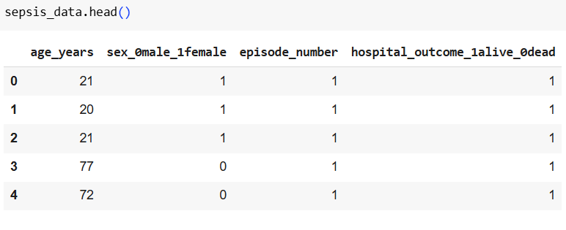

**Figure 4.1: Dataset Considered for this Work**

(Source: Self-Created)

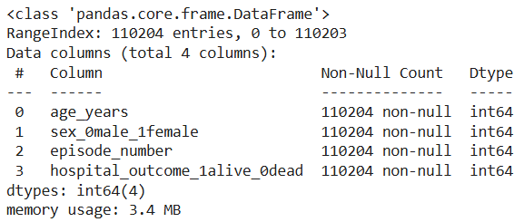

**Figure 4.2: Structure of the Dataset**

(Source: Self-Created)

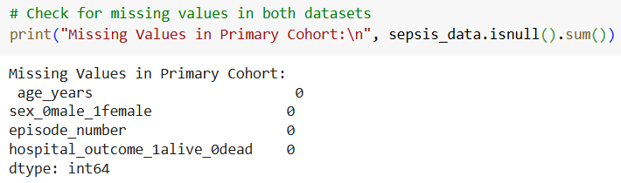

**Figure 4.3: Checking Missing Values in the Dataset**

(Source: Self-Created)

Boxplot analysis of the age_years feature indicated outliers on the lesser end of the circulation. Upon using the Interquartile Variation (IQR) method, extreme values below 6 years were cleared away. This modification decreased sound in the dataset while maintaining the majority of authentic age access. The cleaned dataset possessed an age range of 6 to one hundred years, along with a mean age of 65.8 years. Getting rid of outliers ensured the dataset much better exemplified the common adult sepsis population, improving the reliability of downstream reviews.

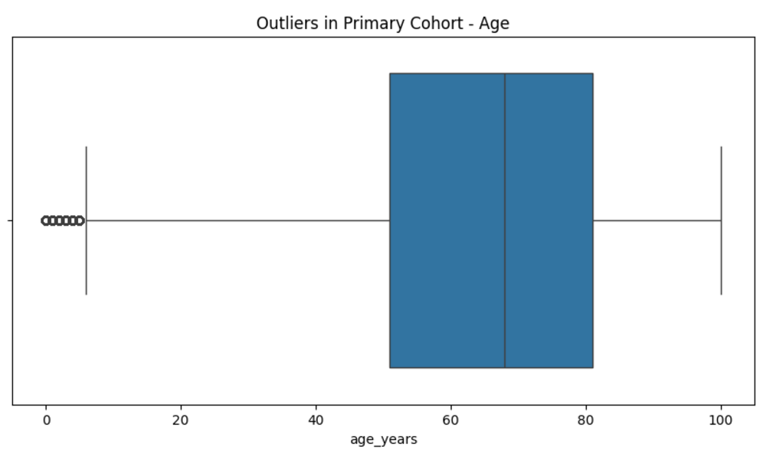

**Figure 4.4: Checking Outliers in Age Column**

(Source: Self-Created)

The age distribution in the primary cohort presented a left-skewed design, along with the majority of patients clustered in more mature age. Age binning right into 10-year intervals created an illustratable categorical variable, age_group_10yr, that streamlines demographic segmentation and highlights patterns around age class.

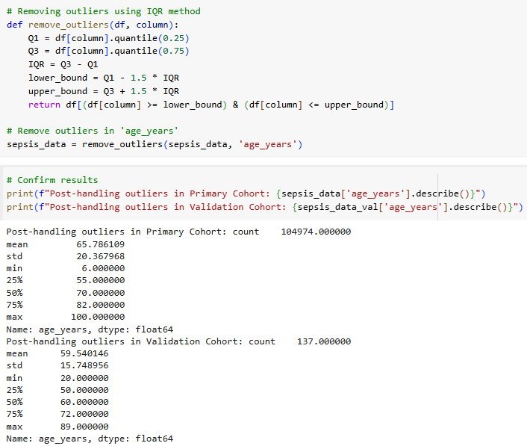

**Figure 4.5: Eliminating Outliers**

(Source: Self-Created)

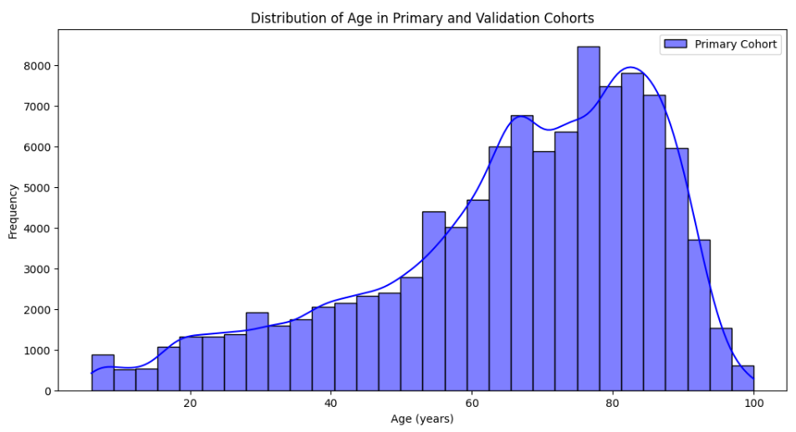

**Figure 4.6: Distribution of Age**

(Source: Self-Created)

Visualization of survival outcomes by age groups disclosed a critical trend: after 40 years, the portion of deceased patients regularly boosted in a nearly linear manner. This straightens with clinical expertise that much older patients go to higher risk of adverse outcomes because of diminished physiological books and improved comorbidities.

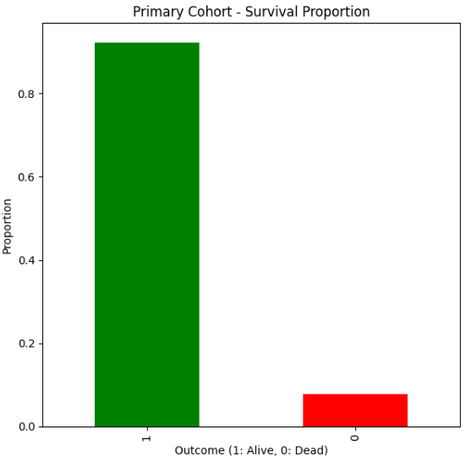

**Figure 4.7: Distribution of Outcome Column**

(Source: Self-Created)

The survival portion in the dataset was greatly imbalanced, with over 90% of patients identified as alive (1) as well as the staying classified as deceased (0 ). This imbalance highlights the need for resampling techniques, such as SMOTE, to resolve bias in model training. Gender-wise survival analysis revealed that, while a lot more men stood for generally, the proportion of deceased guys surpassed that of women. However, the difference was small, and additionally investigation would certainly be required to confirm its own value.

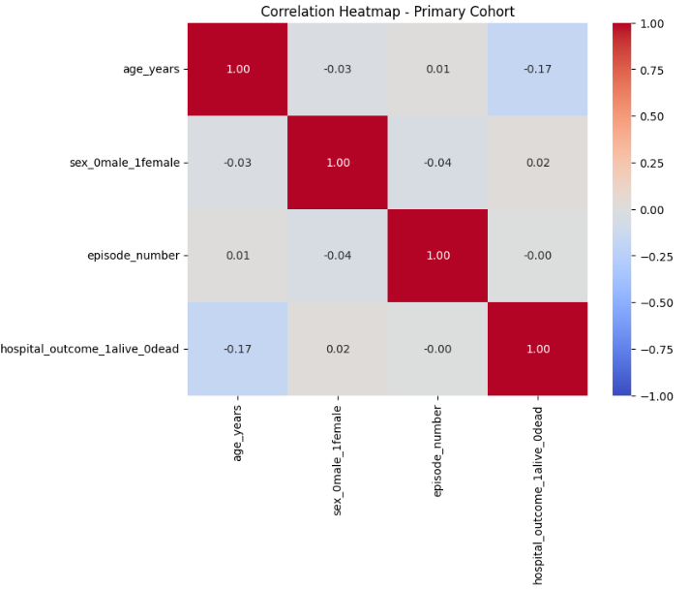

**Figure 4.8: Correlation between the Variables**

(Source: Self-Created)

A heatmap of attribute relationships showed weak linkages in between variables, with the best being between age and medical facility end result (hospital_outcome_1alive_0dead), at -0.17. This bad connection recommends that much older age is connected with a slightly higher possibility of death, coordinating with monitored patterns in clinical outcomes. Other features, including gender, showed minimal correlations with outcomes, emphasizing the necessity for additional crafted features, such as generation or clinical measures, to improve predictive choices in.

The pairplot analysis, making use of KDE for angled distributions, highlighted distinctive survival patterns. While overlaps existed in between alive as well as deceased groups for lots of features, age displayed some difference. More mature patients had a tendency to cluster extra greatly in the deceased group. Nevertheless, other features, including gender as well as incident amount, presented minimal separation in between the classes. This analysis verifies that age and its own crafted variations (e.g., age containers) are among the best critical forecasters.

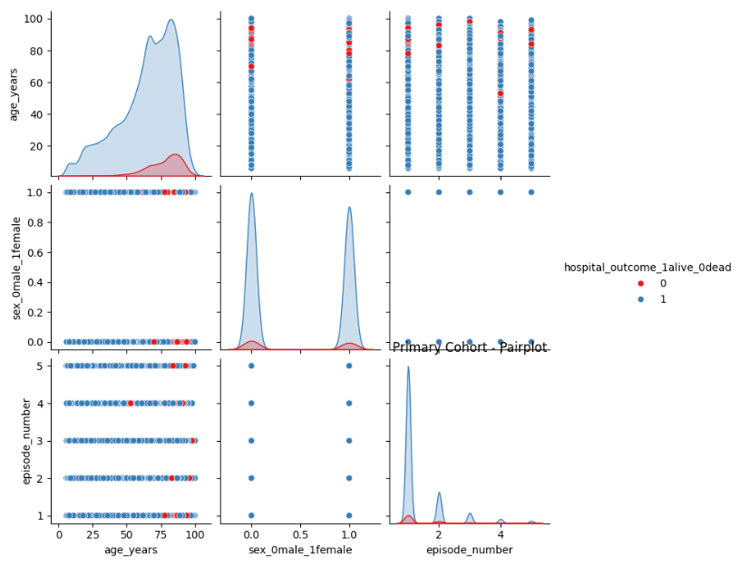

**Figure 4.9: Pairplot for analyzing connection between variables**

(Source: Self-Created)

Countplots displayed that one of deceased patients, males, were overrepresented compared to women throughout every age group. When stratified through age, this trend continued, but the general mortality rate enhanced linearly with age, irrespective of gender. This finding bolsters the requirement to feature age as a critical attribute in predictive choices while thinking about gender as a secondary demographic element.

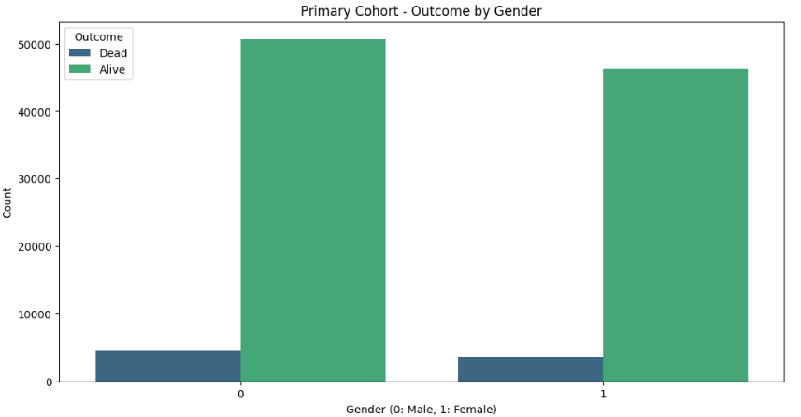

**Figure 4.10: Distribution of Outcome based on Gender**

(Source: Self-Created)

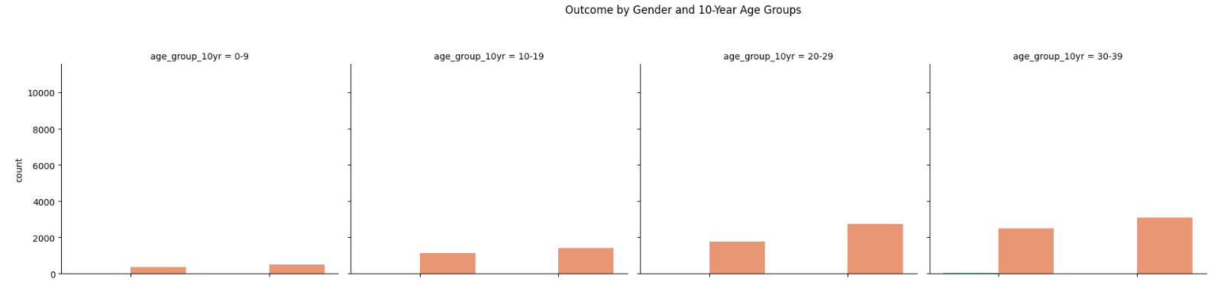

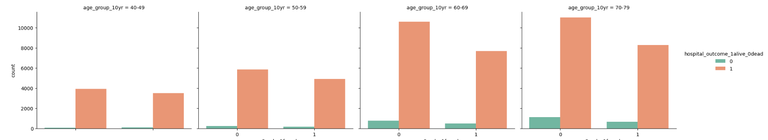

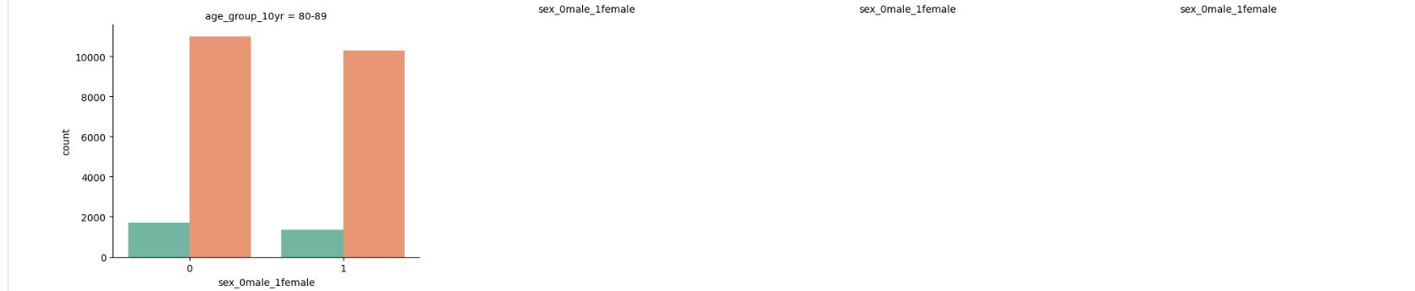

**Figure 4.11: Outcome by Gender and 10-Year Age Groups**

(Source: Self-Created)

Segmenting survival outcomes through generation and gender revealed that age has a stronger impact on mortality than gender. Starting from the 40-- 49 generation, mortality rates enhanced greatly, demonstrating age-related susceptibility. Visualization of these patterns offers a compelling narrative for the critical part held in predictive choices. This analysis verifies that sepsis survival outcomes are significantly affected by age, along with older patients at higher risk. The data additionally highlights gender variations in mortality, though these variations show up much less evident. The imbalance in survival outcomes necessitates the use of resampling techniques to boost model performance.

# Reference List

Agnello, L., Vidali, M., Padoan, A., Lucis, R., Mancini, A., Guerranti, R., Plebani, M., Ciaccio, M. and Carobene, A., 2023. Machine learning algorithms in sepsis. *Clinica Chimica Acta*, p.117738.

Aguirre, U. and Urrechaga, E., 2023. Diagnostic performance of machine learning models using cell population data for the detection of sepsis: a comparative study. *Clinical Chemistry and Laboratory Medicine (CCLM)*, *61*(2), pp.356-365.

Alanazi, A., Aldakhil, L., Aldhoayan, M. and Aldosari, B., 2023. Machine Learning for Early Prediction of Sepsis in Intensive Care Unit (ICU) Patients. *Medicina*, *59*(7), p.1276.

Bedoya, A.D., Futoma, J., Clement, M.E., Corey, K., Brajer, N., Lin, A., Simons, M.G., Gao, M., Nichols, M., Balu, S. and Heller, K., 2020. Machine learning for early detection of sepsis: an internal and temporal validation study. *JAMIA open*, *3*(2), pp.252-260.

Bomrah, S., Uddin, M., Upadhyay, U., Komorowski, M., Priya, J., Dhar, E., Hsu, S.C. and Syed-Abdul, S., 2024. A scoping review of machine learning for sepsis prediction-feature engineering strategies and model performance: a step towards explainability. *Critical Care*, *28*(1), p.180.

Burdick, H., Pino, E., Gabel-Comeau, D., Gu, C., Roberts, J., Le, S., Slote, J., Saber, N., Pellegrini, E., Green-Saxena, A. and Hoffman, J., 2020. Validation of a machine learning algorithm for early severe sepsis prediction: a retrospective study predicting severe sepsis up to 48 h in advance using a diverse dataset from 461 US hospitals. *BMC medical informatics and decision making*, *20*, pp.1-10.

Deng, H.F., Sun, M.W., Wang, Y., Zeng, J., Yuan, T., Li, T., Li, D.H., Chen, W., Zhou, P., Wang, Q. and Jiang, H., 2022. Evaluating machine learning models for sepsis prediction: A systematic review of methodologies. *Iscience*, *25*(1).

Ericson, O., Hjelmgren, J., Sjövall, F., Söderberg, J. and Persson, I., 2022. The potential cost and cost-effectiveness impact of using a machine learning algorithm for early detection of sepsis in intensive care units in Sweden. Journal of health economics and outcomes research, 9(1), p.101.

Fleuren, L.M., Klausch, T.L., Zwager, C.L., Schoonmade, L.J., Guo, T., Roggeveen, L.F., Swart, E.L., Girbes, A.R., Thoral, P., Ercole, A. and Hoogendoorn, M., 2020. Machine learning for the prediction of sepsis: a systematic review and meta-analysis of diagnostic test accuracy. *Intensive care medicine*, *46*, pp.383-400.

Gao, J., Lu, Y., Ashrafi, N., Domingo, I., Alaei, K. and Pishgar, M., 2024. Prediction of Sepsis Mortality in ICU patients using machine learning methods. *BMC Medical Informatics and Decision Making*, *24*(1), p.228.

Giacobbe, D.R., Signori, A., Del Puente, F., Mora, S., Carmisciano, L., Briano, F., Vena, A., Ball, L., Robba, C., Pelosi, P. and Giacomini, M., 2021. Early detection of sepsis with machine learning techniques: a brief clinical perspective. *Frontiers in medicine*, *8*, p.617486.

Honoré, A., Forsberg, D., Adolphson, K., Chatterjee, S., Jost, K. and Herlenius, E., 2023. Vital sign‐based detection of sepsis in neonates using machine learning. *Acta Paediatrica*, *112*(4), pp.686-696.

Islam, K.R., Prithula, J., Kumar, J., Tan, T.L., Reaz, M.B.I., Sumon, M.S.I. and Chowdhury, M.E., 2023. Machine learning-based early prediction of sepsis using electronic health records: a systematic review. *Journal of clinical medicine*, *12*(17), p.5658.

Kijpaisalratana, N., Sanglertsinlapachai, D., Techaratsami, S., Musikatavorn, K. and Saoraya, J., 2022. Machine learning algorithms for early sepsis detection in the emergency department: A retrospective study. *International Journal of Medical Informatics*, *160*, p.104689.

Lin, P.C., Chen, K.T., Chen, H.C., Islam, M.M. and Lin, M.C., 2021. Machine learning model to identify sepsis patients in the emergency department: Algorithm development and validation. *Journal of personalized medicine*, *11*(11), p.1055.

Mahyoub, M.A., Yadav, R.R., Dougherty, K. and Shukla, A., 2023. Development and validation of a machine learning model integrated with the clinical workflow for early detection of sepsis. *Frontiers in Medicine*, *10*, p.1284081.

Misra, D., Avula, V., Wolk, D.M., Farag, H.A., Li, J., Mehta, Y.B., Sandhu, R., Karunakaran, B., Kethireddy, S., Zand, R. and Abedi, V., 2021. Early detection of septic shock onset using interpretable machine learners. *Journal of Clinical Medicine*, *10*(2), p.301.

Moor, M., Rieck, B., Horn, M., Jutzeler, C.R. and Borgwardt, K., 2021. Early prediction of sepsis in the ICU using machine learning: a systematic review. *Frontiers in medicine*, *8*, p.607952.

O’Sullivan, C., Tsai, D.H.T., Wu, I.C.Y., Boselli, E., Hughes, C., Padmanabhan, D. and Hsia, Y., 2023. Machine learning applications on neonatal sepsis treatment: a scoping review. *BMC Infectious Diseases*, *23*(1), p.441.

Ocampo-Quintero, N., Vidal-Cortés, P., del Río Carbajo, L., Fdez-Riverola, F., Reboiro-Jato, M. and Glez-Peña, D., 2022. Enhancing sepsis management through machine learning techniques: A review. *Medicina intensiva*, *46*(3), pp.140-156.

Persson, I., Östling, A., Arlbrandt, M., Söderberg, J. and Becedas, D., 2021. A machine learning sepsis prediction algorithm for intended intensive care unit use (NAVOY Sepsis): proof-of-concept study. *JMIR formative research*, *5*(9), p.e28000.

Prasad, V., Aydemir, B., Kehoe, I.E., Kotturesh, C., O’Connell, A., Biebelberg, B., Wang, Y., Lynch, J.C., Pepino, J.A., Filbin, M.R. and Heldt, T., 2023. Diagnostic suspicion bias and machine learning: Breaking the awareness deadlock for sepsis detection. *PLOS Digital Health*, *2*(11), p.e0000365.

Singh, Y.V., Singh, P., Khan, S. and Singh, R.S., 2022. [Retracted] A Machine Learning Model for Early Prediction and Detection of Sepsis in Intensive Care Unit Patients. *Journal of Healthcare Engineering*, *2022*(1), p.9263391.

Steinbach, D., Ahrens, P.C., Schmidt, M., Federbusch, M., Heuft, L., Lübbert, C., Nauck, M., Gründling, M., Isermann, B., Gibb, S. and Kaiser, T., 2024. Applying machine learning to blood count data predicts sepsis with ICU admission. *Clinical Chemistry*, *70*(3), pp.506-515.

Wang, H., Li, Y., Naidech, A. and Luo, Y., 2022. Comparison between machine learning methods for mortality prediction for sepsis patients with different social determinants. *BMC medical informatics and decision making*, *22*(Suppl 2), p.156.

Yan, M.Y., Gustad, L.T. and Nytrø, Ø., 2022. Sepsis prediction, early detection, and identification using clinical text for machine learning: a systematic review. *Journal of the American Medical Informatics Association*, *29*(3), pp.559-575.

Yang, H.S., 2024. Machine Learning for Sepsis Prediction: Prospects and Challenges. *Clinical Chemistry*, *70*(3), pp.465-467.

Zhang, W.Y., Chen, Z.H., An, X.X., Li, H., Zhang, H.L., Wu, S.J., Guo, Y.Q., Zhang, K., Zeng, C.L. and Fang, X.M., 2023. Analysis and validation of diagnostic biomarkers and immune cell infiltration characteristics in pediatric sepsis by integrating bioinformatics and machine learning. *World Journal of Pediatrics*, *19*(11), pp.1094-1103.